Situation
You are Chris Wong, a summer intern in Green Footprint Hong Kong, which is a non-profit making environmental group. Mr Norman Cheung, your supervisor, has asked you to write an article on the use of electric vehicles (EVs) for the upcoming newsletter.

In the article, discuss the reasons for the unpopularity of EVs in the first part and suggest ways to promote their wider use in the second part.

Task 1: Identifying Causes
- Mr Cheung has asked you to watch the following video to identify problems and concerns related to the use of EVs which may explain their unpopularity.
EVs’ Serious Problems That Carmakers Are Hiding (8 minutes 21 seconds)
https://www.youtube.com/watch?v=CaoqWcHsE_g

As you watch, take down the key ideas using the fishbone diagram on the next page. Put the main problems in the oval bubbles and the supporting details in the rectangular boxes.

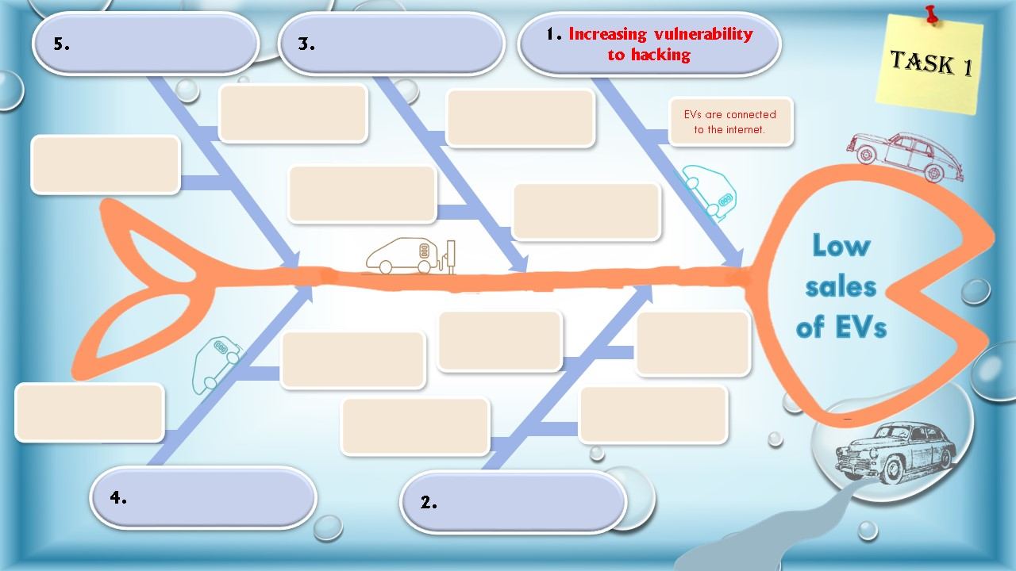
Main problem
Supporting details

- Select three main problems of EVs from the fishbone diagram that best explain the low sales of EVs. Make three topic sentences for the first part of the article.

The expressions below may help you present the cause-and-effect relationship.
- Cause causes/leads to/brings about/results in/contributes to result.
- Cause is a cause of/the origin of/a contributing factor to result.
- Result stems from/results from/arises from/is caused by/can be attributed to cause.
- The root/main cause/origin of result is cause. // The reason for result is cause.

Examples:
- Drivers’ reluctance to change leads to the low sales of electric vehicles.
- The lack of choice available to drivers is a contributing factor to the unpopularity of electric vehicles.

Notes: Nouns/noun phrases are used to present the cause-and-effect relationship in a more formal tone and style.
(cf.: Electric vehicles do not sell well because drivers are reluctant to change.)

Write your three topic sentences to present the three strongest reasons:
Topic Sentences
Reason 1
Reason 2
Reason 3

Task 2: Suggesting Solutions/Possible Actions
- Mr Cheung sent you an email with some useful information on possible ways to promote the use of EVs. Read his email and complete the attached mind map following his instructions.
To: Chris Wong Sent: Mon 25 July 2022 3:14PM
From: Norman Cheung
Subject: Useful info on the second part of the article on EVs
Dear Chris,
I did a bit of online research and found some useful information that may help you write the second part of the article on ways to make EVs more popular.
With the additional resources I found, I think we can address the topic using a stakeholder approach and suggest ways that car manufacturers, drivers and the Government can help make EVs more widely used. I have made a mind map to show this and you may use it to organise the ideas you get from different sources.

You can rewatch the clip I sent you earlier on to jot down key ideas on what car manufacturers and drivers can do. Here is the link again:
EVs’ Serious Problems That Carmakers Are Hiding (8 minutes 21 seconds)
https://www.youtube.com/watch?v=CaoqWcHsE_g
I know that car manufacturers in China are also currently doing a lot to make EVs more popular. The video from China Current below may help enrich the part on what else car manufacturers can do.
Electric Vehicles You’ll Want to Know About (2 minutes)
https://chinacurrent.com/story/23436/electric-vehicles-youll-want-to-know-about
The Government is a key player. Don’t forget to count it in. Some useful ideas are provided in the following website of the Council for Sustainable Development.
Promoting the Use of Electric Vehicles (EVs)
https://www.susdev.org.hk/elearning/en/resources-electric-car.php
You can jot down and organise the useful ideas using the mind map first and we can discuss further in the meeting on Friday. Thanks for your hard work.
Regards
Norman

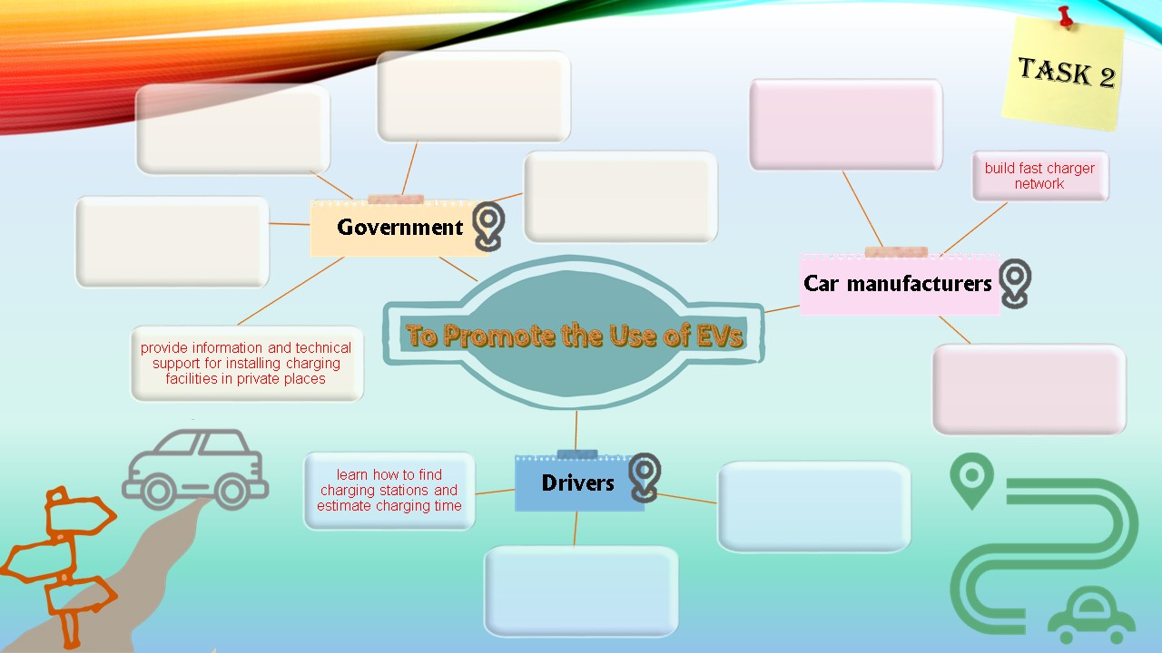
- You are going to use the ideas in the mind map to write the second part of the article. The expressions below may help you suggest what different stakeholders can do to promote the use of EVs:
To introduce the roles of different stakeholders | - Stakeholder group play a(n) important/prominent/pivotal/vital/ key/crucial role in …  - As for stakeholder group, …  - Stakeholder group can also help in…
To suggest solutions | - The government can/may/should/must modal verbs…  - Drivers are encouraged/recommended/advised the passive voice to…  - It is advisable/important/necessary/essential adjectives (for stakeholder group) to…

Addressing reasons/problems mentioned earlier
Example:
Car manufacturers play a key role in relieving drivers’ concerns about battery life. They can improve the design of the batteries to shorten the charging time. It is also advisable for car manufacturers to expand the network of fast chargers so that high speed charging is more accessible to drivers. In this way, drivers’ range anxiety can be alleviated.

Choose another stakeholder group from the mind map. Write a paragraph to offer suggestions on what they can do to promote the use of EVs following the sample paragraph above.

Task 3: Writing an Article for the Newsletter
Write the article on the use of electric cars for the upcoming newsletter of Green Footprint Hong Kong. In the article, discuss the reasons for the unpopularity of EVs and suggest ways to promote their wider use.

